Purpose of the chapter
- Define a project
- Define project success
- Project constraints
- Project management expertise
- The project environment
- Project management knowledge and skills

Define a project
- Unique product or service
- Time-limited
- The project ends when the objectives are achieved or abandoned

How can you tell that an activity is unique?
- Completely new product or service
- Creation of a new process
- Product or service new to this group of people

Time-limited
- May have a start and end date
- May be measured as “will be complete when a particular objective is achieved”
- If it simply continues forever or to an unspecified end date it is probably an ongoing business activity

Can tell when it is done
- Objective is achieved
- The time limit is reached
- Objective is abandoned

Project Success
- Traditionally: on time, within budget and delivers the promised scope
- More effective measure: satisfied customer

Group work
- In small groups, try to identify the LARGEST project each of you has been involved with.
- You do not have to have been the project manager—if not, what was your role? (team member, volunteer, purchaser, ??)
- With the group, make it clear how the project you have identified meets the criteria:
  - Unique
  - Temporary

Project constraints
- Cost
- Scope
- Quality
- Risk
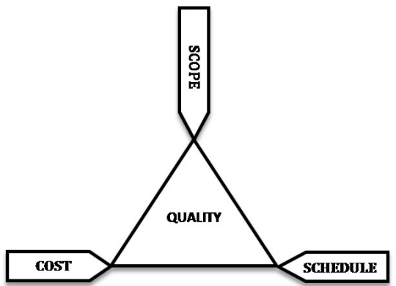
- Resources
- Time

Triple constraint
All the constraints can be grouped into these three:

Project Management Expertise
- Application knowledge
  - Industry group
  - Technical speciality
  - Managerial area
- Understanding the project environment
  - Cultural
  - Social
  - Political
  - International
  - physical
- Management knowledge and skills
- Interpersonal skills
  - Communication
  - Influence
  - Leadership
  - Motivation
  - Negotiation
  - Problem-solving

Project Management Standards
- Standards organizations
- PMI
  - Project Management Institute: http://www.pmi.org/
  - CAPM, PMP and other professional standards
- IPMA
  - International Project Management Association: http://ipma.ch/
  - Several certifications

Summary
- Project definition: unique, time-limited, can tell when it is over
- Project success: a satisfied client
- Project constraints: time, scope, cost
- Project management expertise
- The project environment
- Project management knowledge and skills

